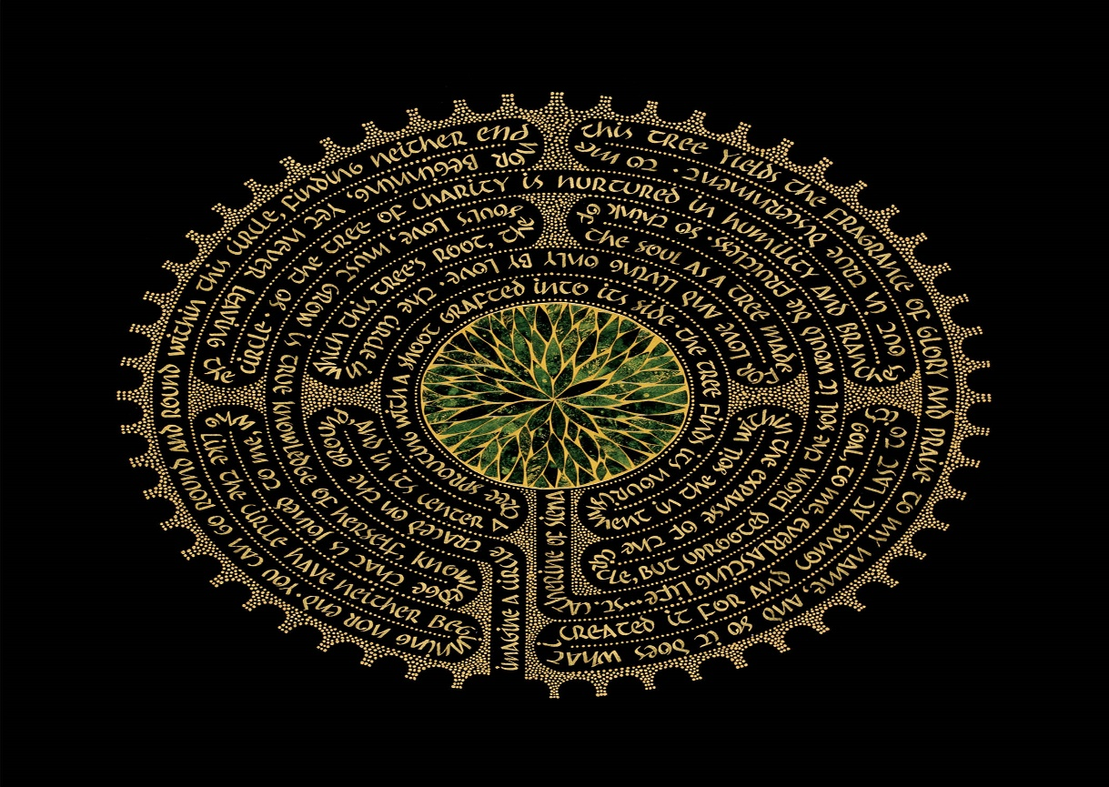
Pilgrim’s Walk

This is a small group for people in the 3rd stage of life (age 65 to end of life) focusing on spiritual growth and honest conversation about what is real for people in this last stage of life.

Priorities are inclusive participation in a supportive environment and focus on our relationship to God, the Source of our Being. This is an inter-faith group where accepting differences of faith is important as we gather together around our common search for the sacred.

This group focuses on building small supportive and caring community and topics include loss, grief, forgiveness, finding purpose in aging, giving to others and focusing on self needs, death and dying, family and love, loneliness due to degenerative illness or limitations of aging, ageism, joys of retirement and leisure time.

There are 3 types of groups and they can be offered in sequence: PW 1 (6 sessions), Monthly support group ( 6 sessions) and PW 2 (6 sessions). We begin with meditation and end with prayer and sometimes ritual. Interfaith texts are incorporated.

For more information about how to have a group started at your church or community living center contact Rev Susan Vincent Cox 518) 796-8793 or see more at firstchurchinalbany.org

